Kem Andrew
Sort Compare
CMPS 3013 - Program 3: Sort Compare
4/7/2015

The goal of this project was to determine the performance of different sorting algorithms.

The following algorithms were chosen:
Quick Sort - O (nlogn)
Merge Sort - O (nlogn)
Insertion Sort - O (n^2)
Bubble Sort - O (n^2)

In order of time performance:
1. Quick Sort
2. Merge Sort
3. Insertion Sort
4. Bubble Sort
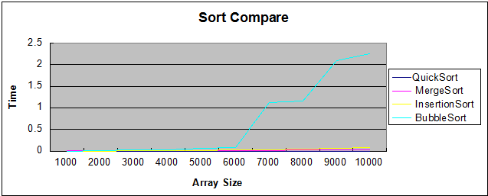

In order of number of comparisons:
1. Quick Sort
2. Merge Sort
3. Insertion Sort
4. Bubble Sort

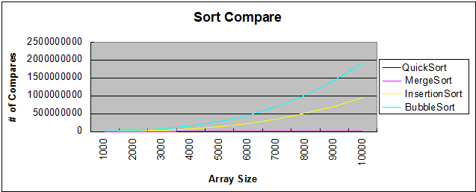

From this data, it can be safely concluded that the number of comparisons is directly linked to the time the algorithm takes to run i.e. Algorithms with less comparisons generally perform better at sorting data.

The major problems encountered during this project was finding sorting algorithms that worked. Merge Sort proved to be the most complex algorithm of the four, thus making difficult to understand and implement. The complexity of the Merge sort algorithm can also be thought to tie into its performance as well.

